25CS2205E - ADVANCED OBJECT ORIENTED PROGRAMMING

Week – 1

- Create a class Student with student ID, name and age. Create three student objects and display their details.

Code :

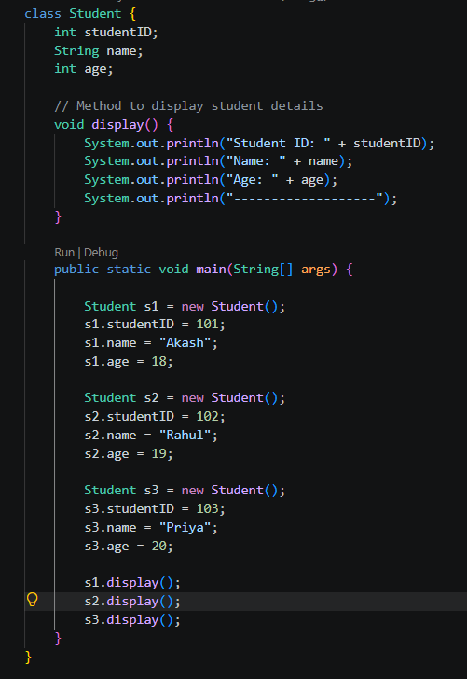Output :

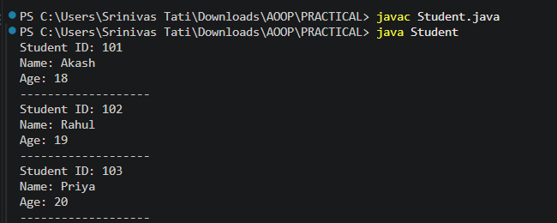

- Create an Employee class with employee ID, name and salary. Initialize the values using a constructor and display employee details.
Code:
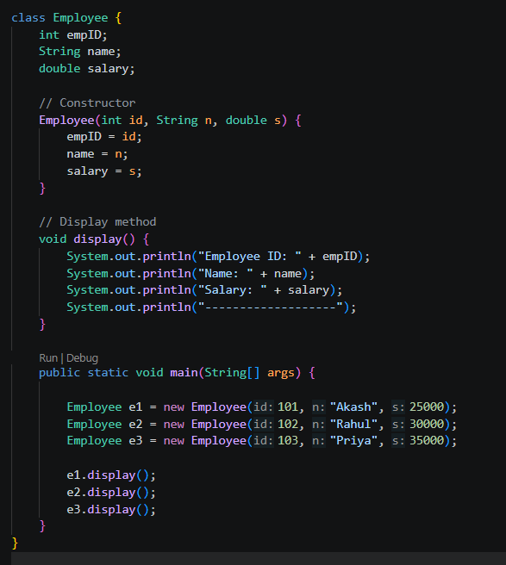
Output:
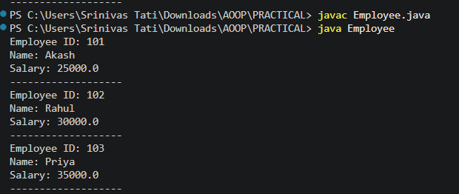

3.Create a BankAccount class with account number and balance. Implement deposit and withdrawal methods.
Code:
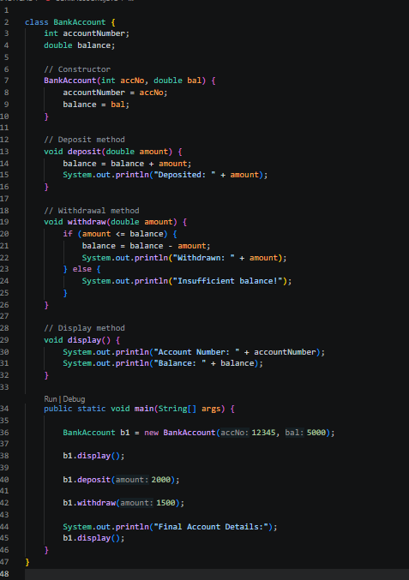
Output:
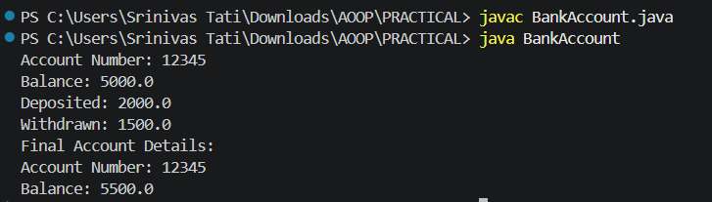

4.Create a Rectangle class with length and width. Calculate and display its area and perimeter.

Code:
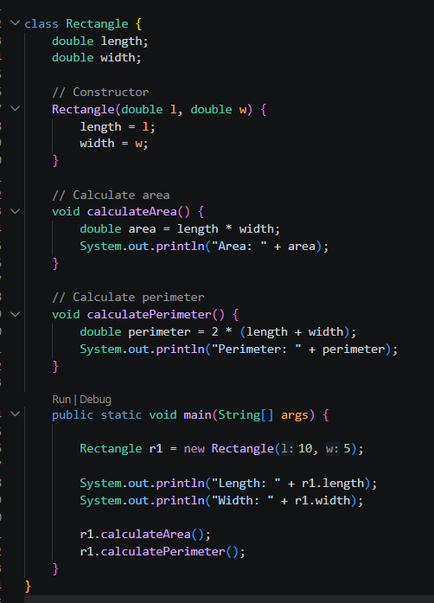
Output:
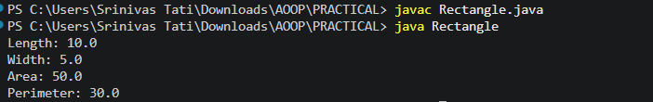

5. Create a Book class with ISBN, title and price. Initialize the values using a parameterized constructor.

Code:
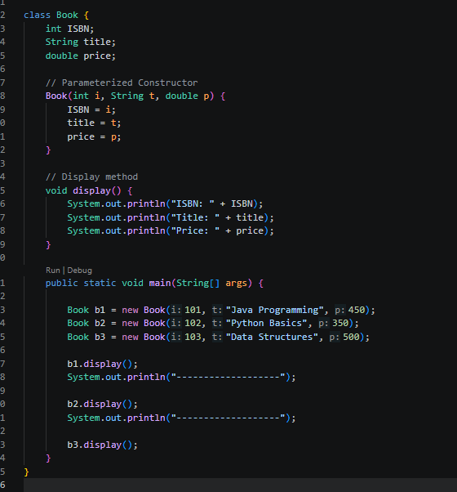

Output:


